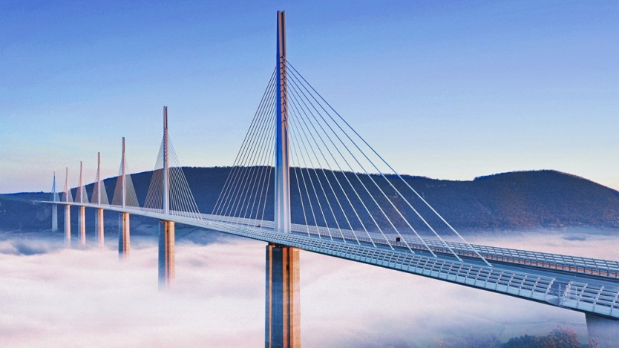**Millau Viaduct**

The Millau Viaduct (French: Viaduc de Millau) is a cable-stayed viaduct spanning the river Tarn valley in Millau, Aveyron province, southern France. Bridge by architect British Norman Foster and engineers players who France Michel Virlogeux design. This bridge was once considered the tallest in the world and is still the bridge with the highest pylon in the world. If the height of the road surface on the bridge is 270 m below the ground, currently (2017) is the 22nd tallest bridge in the world, partly because the bridge is built at the bottom of the valley, but is the tallest bridge in the world. gender (by structure). The highest point of the bridge, from the foot of the tallest pylon P2 to the top of the cable-stayed pillar is 343m, is the tallest structure in France, higher than the Eiffel Tower, so high that the bridge is hovering above the clouds in the Tarn valley, 2.5 km wide and 250 meters deep. Wind speed over the bridge can be up to over 200 km/h. This bridge is part of the A75-A71 road transport axis from Paris to Béziers

The record build

The construction of this bridge has broken three world records: The tallest pillar tower in the world: P2 and P3 towers, respectively 244.96m and 221.05m, breaking the previous French record set by the Tulle and Verrières viaducts (141 m), and a record the previous world, held by the Kochertal Viaduct (Germany), was 181m high at the time of its highest point; The tallest column in the world: the top of the P2 tower is 343 m high. The highest viaduct deck in the world, 270 m high on the Tarn River at the highest point. It is almost double the height of the previous tallest bridge in Europe, Europabrücke in Austria. It is slightly taller than the New River Canyon Bridge in West Virginia in the United States, with a height of 267m on the New River. Only the Royal Gorge Bridge floor in Colorado, USA (primarily a pedestrian bridge across the Arkansas River, sometimes also used by motorbikes) is taller at a height of 321 m, and is considered a bridge the world's highest.